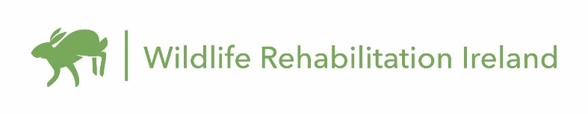
Job title: Wildlife Veterinary Nurse Intern
Reports to: Hospital Manager
Supervises: Wildlife interns and volunteers
Start Date: Immediate
WRI’s Wildlife Hospital, the only dedicated wildlife hospital in Ireland, is currently offering a full-time internship for a Wildlife Veterinary Nurse.
Working alongside the Animal Manager, the Veterinary Nurse will have responsibilities in all aspects of medical care for Ireland’s injured, ill, and orphaned wildlife.

Position Summary
The Wildlife Veterinary Nurse is a member of the WRI Wildlife Hospital Veterinary team, reporting directly to the Hospital Manager. The Veterinary Nurse is responsible for the daily medical care of wildlife patients, including critical care, anaesthesia, examinations, wound care, physical therapy, necropsies, feeding plans, and species-specific husbandry, among other responsibilities.
In conjunction with the Animal Manager, the Veterinary Nurse must be willing to patiently teach and direct staff, interns, and volunteers. The Veterinary Nurse will be part of a growing medical team at WRI Wildlife Hospital.

Duties and Responsibilities
Efficiently and effectively assist in the medical care of wildlife patients.
Ensure the wildlife hospital has the supplies and medications needed to carry out the work on a daily basis.
Identify and suggest ways to improve both medical and rehabilitative care of patients as part of the broader hospital team. These duties ensure the highest standard of care is provided to our wild animal patients.
Be flexible to work varying schedules including work on weekends when needed.
Other Responsibilities
Assist in the creation and compliance of protocols and procedures.
Ensure adherence to local laws and safety rules.
Work closely with colleagues at other centres including rehabilitators and veterinary practice staff.
Adhere to appropriate social distancing and other guidelines during pandemic.
Avail of continuing veterinary education opportunities to ensure we provide the highest-level of care possible for patients.
Qualifications
Registered Veterinary Nurse degree from accredited third level institution, with a minimum of two years of experience as a licensed nurse in the care and treatment of wild animals in a wildlife facility that admits around 1,000 animals/year.
Experience with diagnostic procedures - including radiology and faecal examination.
Experience and knowledge in the natural history and behaviour of native Irish wildlife species preferred.
Up-to-date tetanus and rabies vaccinations.

General Competencies
Follows instructions and responds to management direction.
Listens and responds constructively to others' views.
Gives and welcomes feedback and shares expertise.
Acknowledges others' effort and contribution.
Puts success of team above own interests.
Creates a positive work environment.

Rewards
As the Wildlife Veterinary Nurse Intern, you will receive full bed and board in our large on site apartment. (NB - the rooms in the apartment are shared rooms)

To Apply
Please email office@wri.ie with a filled in application form, your C.V. and a written reference attached. Put “Wildlife Veterinary Nurse” in the subject line.

